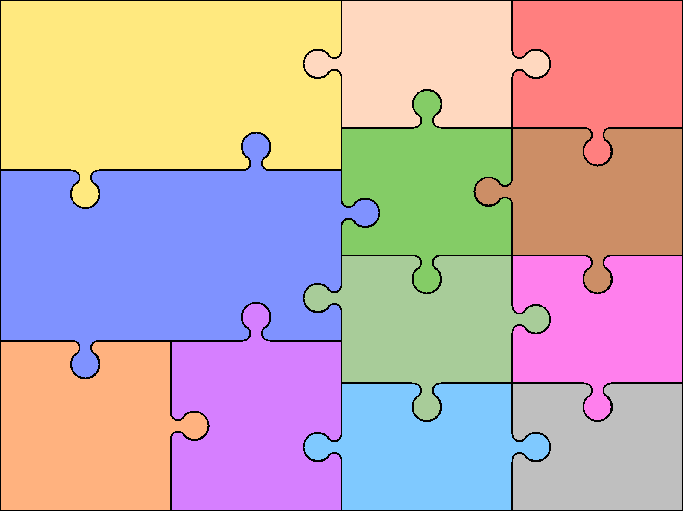  Reading  Secure decoding of unfamiliar words  Read for a range of purposes  Retell some stories orally  Discuss words & phrases that capture the imagination  Identify themes & conventions  Retrieve & record information  Make inferences & justify predictions  Recognise a variety of forms of poetry  Identify & summarise ideas | English  Writing  Correctly spell common homophones  Increase regularity of handwriting  Plan writing based on familiar forms  Organise writing into paragraphs  Use simple organisational devices  Proof-read for spelling & punctuation errors  Evaluate own and others’ writing  Read own writing aloud |  | Grammar  Use wider range of conjunctions  Use perfect tense appropriately  Select pronouns and nouns  for clarity  Use & punctuate direct  speech  Use commas after front adverbials  Recognise & use modal verbs  Use brackets, dashes & commas to add extra information  Speaking & Listening  Articulate & justify opinions  Speak audibly in Standard English  Gain, maintain &  monitor interest of  listeners | Art  Objects and Meaning  Viking Art  Frida Kahlo | Computing  Online safety  Coding  Spreadsheets  Databases  Game creator  3D Modelling
 |  |  |  | Design & Technology  Felt phone cases  Viking Shields  Bread | Geography  Map Skills  The Americas  Waste & Recycling  Mexico
Number/Calculation  Know all tables to 12 x 12  Secure place value to 1000  Use negative whole numbers  Round numbers to nearest 10, 100 or 1000  Use Roman numerals to 100 (C)  Column addition & subtraction up to 4 digits  Multiply & divide mentally  Use standard short and long multiplication and division methods | Mathematics  Geometry & Measures  Compare 2-d shapes, including quadrilaterals & triangles  Find area by counting squares  Calculate rectangle perimeters  Estimate & calculate measures  Identify acute, obtuse & right angles  Identify symmetry  Use first quadrant coordinates  Introduce simple translations  Statistics  Use bar charts, pictograms & line graphs |  | Fractions & decimals  Recognise tenths & hundredths  Identify equivalent fractions  Add & subtract fractions with common denominators  Recognise common equivalents  Round decimals to whole numbers  Solve money problems
 |  |  |  | French (MFL)  Numbers 30 – 100 (10s)  Euros  Countries and continents  Transport  Healthy Eating  Weather and Seasons  Hobbies  French History and Past Tense | Music  Units to Include:  Rap  Soul  Rock  Samba Drumming  Living on a Prayer - Charanga  Fresh Prince of Bel Air – Charanga  Make you feel my Love - Charanga
Science  Forces  Properties and changes of  materials  Earth & Space  Living Things and their habitats |  | History  Tudors  Vikings  Mayans  Local History
 |  |  |  | Physical Education  Dance  Gymnastics/Yoga Outdoor &  Hockey / Lacrosse Adventurous  Tag Rugby  Tennis Netball  Athletics (Indoor/Outdoor)  Badminton  Rounders | Religious Education  Hinduism  Worship  Peace  Buddhism
Curriculum Overview for Year 5

