Spring week 1 Tuesday
Use a number line to work out these additions.

2 + 13 =

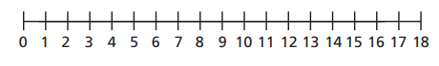

4 + 9 =

1 + 17 =

5 + 12 =

2 + 16 =

8 + 8 =

