Summer Wk7 Wednesday Fractions Finding quarter of an amount
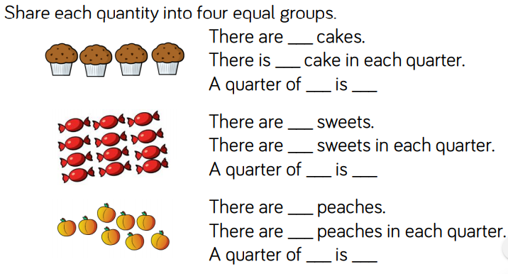

Work out these fractions of amounts using bar models.
Quarter of 16 is

¼ of 12 is

½ of 10 is

¼ of 24 is

¼ of 20 is

