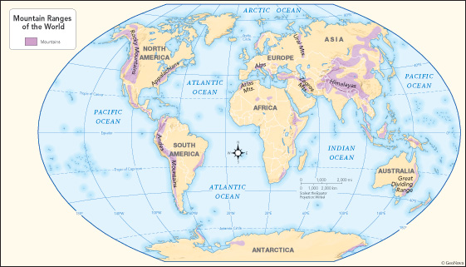
Mountain Ranges of the World Map
Mountain Research Questions
What mountain range are you researching?

How was this mountain range formed?

In which continent is the mountain range found?

How long is the mountain range?

Through which countries does the mountain range go?

What is the capital city of each of these countries?

What is the highest peak of this mountain range? Include its name and height, and in which country it is found.

Has anyone climbed to the summit? If yes, who was the first person, and when did they do it? If no, why has no one climbed it?

Does the mountain range have any glaciers?

What wildlife can be found on this mountain range? Record anything about them, including their habitat, what they eat and whether they are endangered (and why).

Record any other interesting facts about this mountain range.

